**CSS Assignment – A1**

Q1 Ans:-

<!DOCTYPE html>

<html>

    <head>

        <style>

            h1 {

              background-color: blue;

            }

            div {

              background-color: rgb(186, 186, 212);

            }

            p {

              background-color: rgb(251, 250, 255);

            }

        </style>

    </head>

        <title>CSS 1</title>

        <body>

            <h1>CSS background-color example!</h1>

            <div>

                    This is a text inside a div element

                <p>This pararagraph has its own color</p>

                    we are still in div element

            </div>

        </body>

    </head>

</html>

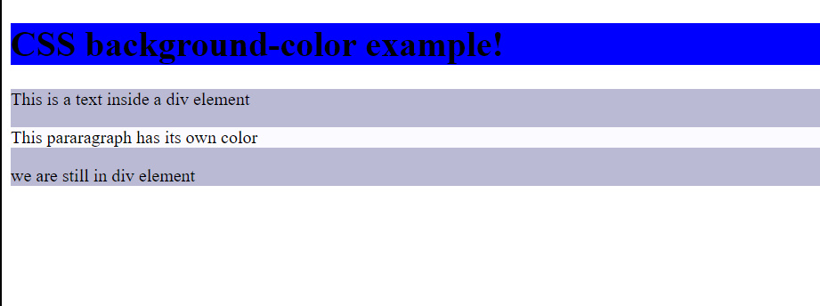

Q2 Ans:-

<!DOCTYPE html>

<html>

    <head>

        <style>

            body {

                background-color: lightblue;

            }

            h2{

                text-decoration:line-through;

            }

            h3{

                text-decoration:underline;

            }

        </style>

    </head>

        <title>CSS 2</title>

        <body>

            <h1>This is heading 1</h1>

            <h2>This is heading 2</h2>

            <h3>This is heading 3</h3>

            <h4>This is heading 4</h4>

        </body>

    </head>

</html>



Q4 Ans:-

<!DOCTYPE html>

<html>

    <head>

        <style>

            a {

                color: red;

              }

        </style>

        <title>CSS 3</title>

        <body>

            <!-- <h2>this is some text</h2>

            <h3>this is some text</h3>

            <h3>this is some text</h3>  -->

            <h2>CSS Links</h2>

            <hr>

            <p><b><a href="default.asp" target="_blank">This is a link</a></b></p>

        </body>

    </head>

</html>

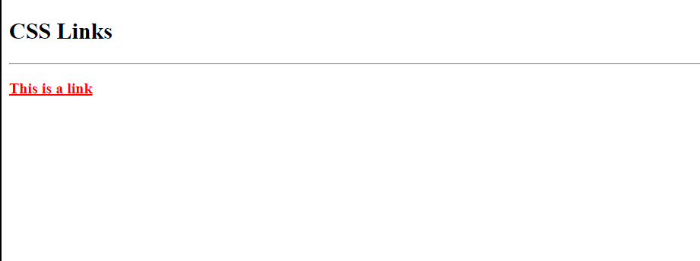

Q5 Ans:-

<!DOCTYPE html>

<html>

    <head>

            <style>

            table, th, td {

                border: 2px solid black;

                border-collapse: collapse;

            }

            </style>

        </head>

    <body>

        <h2>CSS Table 1</h2>

        <hr>

        <table style="width:100%">

            <table>

                <tr>

                    <th>First Name</th>

                    <th>Last Name</th>

                </tr>

                <tr>

                    <td>Peter</td>

                    <td>Griffin</td>

                </tr>

                <tr>

                    <td>Lois</td>

                    <td>Griffin</td>

                </tr>

            </table>

        </table>

    </body>

</html>

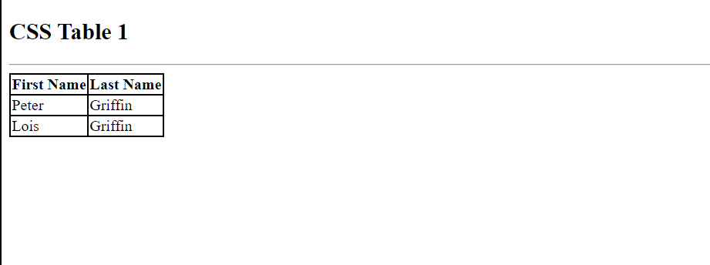

Q6 Ans:-

<!DOCTYPE html>

<html>

    <head>

            <style>

            table, th, td {

                border: 2px solid green;

            }

            th {

                 background-color: #4CAF50;

                 color: white;

            }

            </style>

        </head>

    <body>

        <h2>CSS Table 1</h2>

        <hr>

            <table>

                <tr>

                    <th>First Name</th>

                    <th>Last Name</th>

                    <th>Savings</th>

                </tr>

                <tr>

                    <td>Peter</td>

                    <td>Griffin</td>

                    <td>$100</td>

                </tr>

                <tr>

                    <td>Lois</td>

                    <td>Griffin</td>

                    <td>$150</td>

                </tr>

                <tr>

                    <td>Joe</td>

                    <td>Swanson</td>

                    <td>$300</td>

                </tr>

                <tr>

                    <td>Cleveland</td>

                    <td>Brown</td>

                    <td>$250</td>

                </tr>

            </table>

        </table>

    </body>

</html>

<!DOCTYPE html>

<html>

    <head>

            <style>

            table, th, td {

                border: 2px solid green;

            }

            th {

                 background-color: #4CAF50;

                 color: white;

            }

            </style>

        </head>

    <body>

        <h2>CSS Table 1</h2>

        <hr>

            <table>

                <tr>

                    <th>First Name</th>

                    <th>Last Name</th>

                    <th>Savings</th>

                </tr>

                <tr>

                    <td>Peter</td>

                    <td>Griffin</td>

                    <td>$100</td>

                </tr>

                <tr>

                    <td>Lois</td>

                    <td>Griffin</td>

                    <td>$150</td>

                </tr>

                <tr>

                    <td>Joe</td>

                    <td>Swanson</td>

                    <td>$300</td>

                </tr>

                <tr>

                    <td>Cleveland</td>

                    <td>Brown</td>

                    <td>$250</td>

                </tr>

            </table>

        </table>

    </body>

</html>

Q7 Ans:-

<!DOCTYPE html>

    <html>

        <head>

            <style>

                h2.out {

                    border: 3px solid red;

                    outline-style: dotted;

                    outline-color: green;

                }

            </style>

        </head>

        <body>

            <h2 class="out">Note: IE8 supports outline properties only if a !Doctype is <br> specified.</h2>

        </body>

</html>

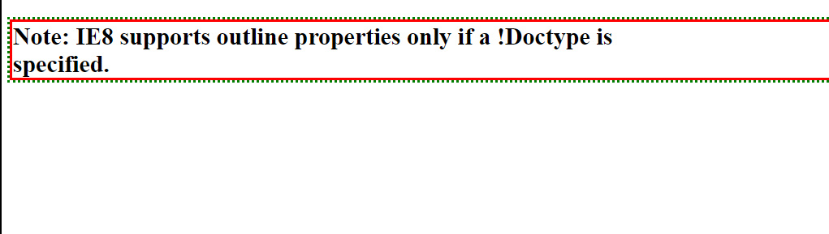

Q9 Ans:-

<!DOCTYPE html>

    <html>

        <head>

            <style>

               h3.out1 {

                    border: 1px solid black;

                    outline-style: solid;

                    outline-color: black;

                    outline-width: 8px;

                }

                h3.out2 {

                    border: 1px solid black;

                    outline-style: solid;

                    outline-color: black;

                    outline-width: thick;

                }

                h3.out3 {

                    border: 1px solid black;

                    outline-style: solid;

                    outline-color: black;

                    outline-width: medium;

                }

                h3.out4 {

                    border: 1px solid black;

                    outline-style: solid;

                    outline-color: black;

                    outline-width: thin;

                }

            </style>

        </head>

        <body>

            <h3 class="out1">Note: IE8 supports outline properties only if a !Doctype is specified.</h3><br><br>

            <h3 class="out2">Note: IE8 supports outline properties only if a !Doctype is specified.</h3><br><br>

            <h3 class="out3">Note: IE8 supports outline properties only if a !Doctype is specified.</h3><br><br>

            <h3 class="out4">Note: IE8 supports outline properties only if a !Doctype is specified.</h3><br><br>

        </body>

</html>

